**configure MFA for aws account** :- first we need to create aws account and then click on Identity and Access management (IAM) and it will ask for Authenticator for MFA and scan the QR code then get the code from the Authenticator App and then enter the MFA code then it will be shown like this

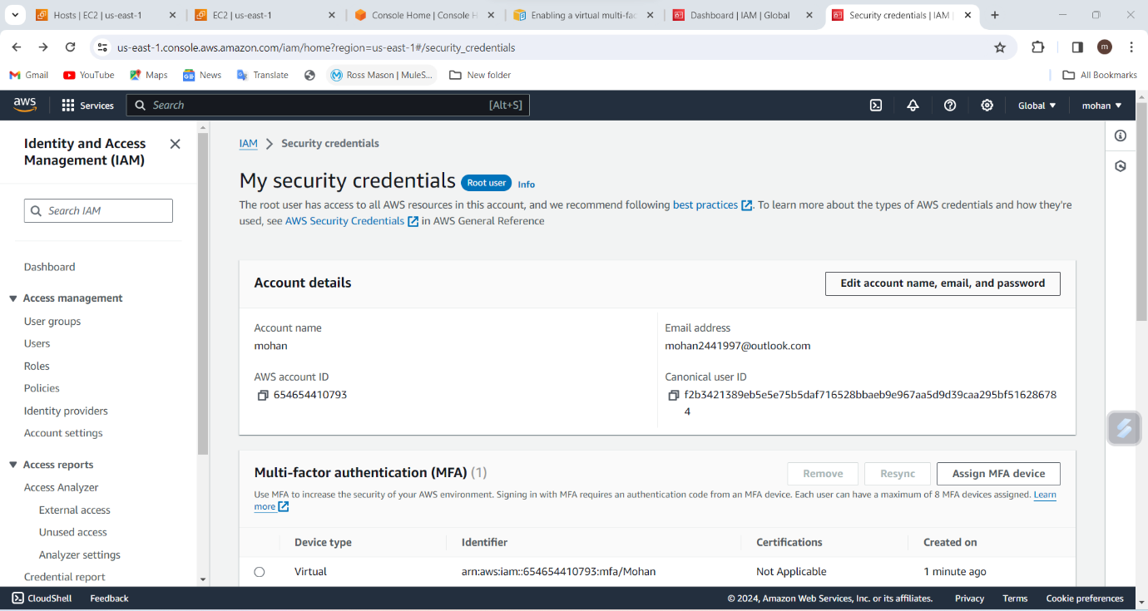

Install aws cli in windows:-

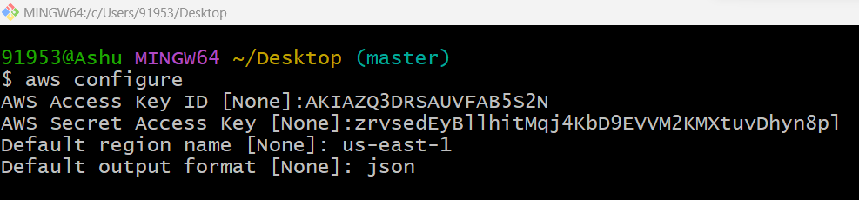

Setup ec2 in N.virginia region using aws cli command:-

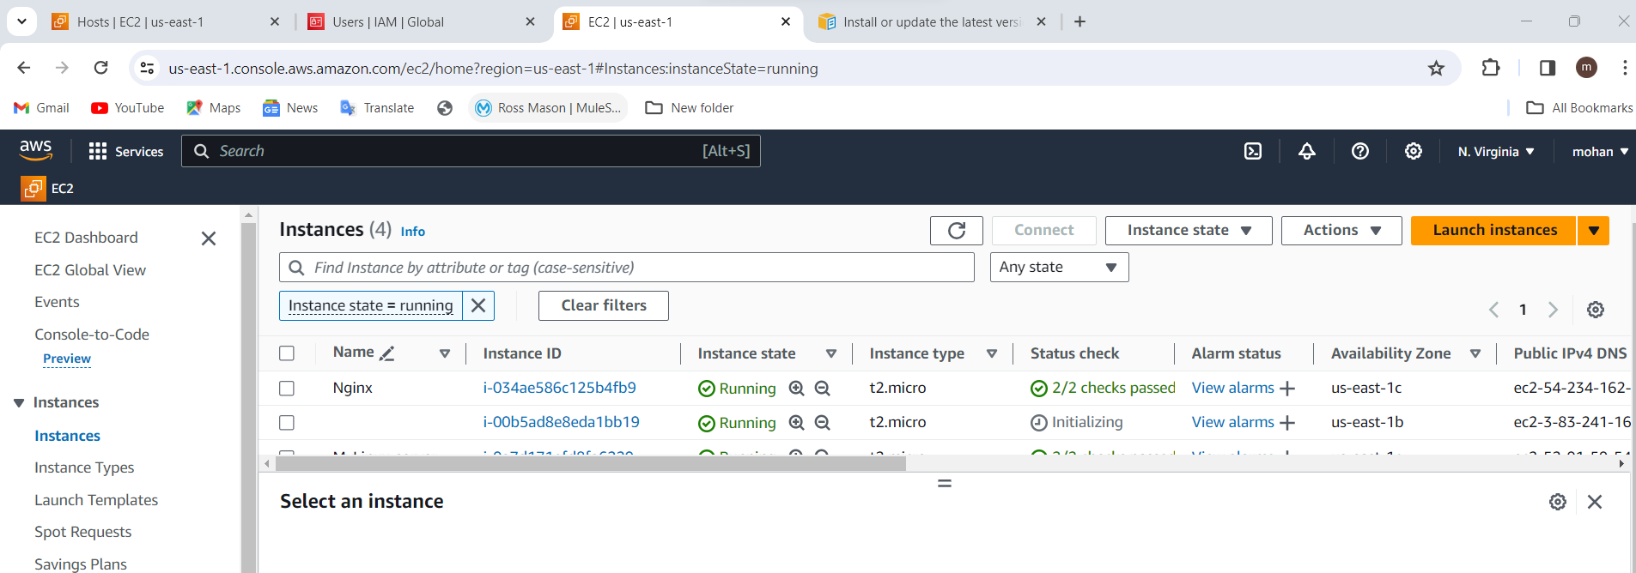

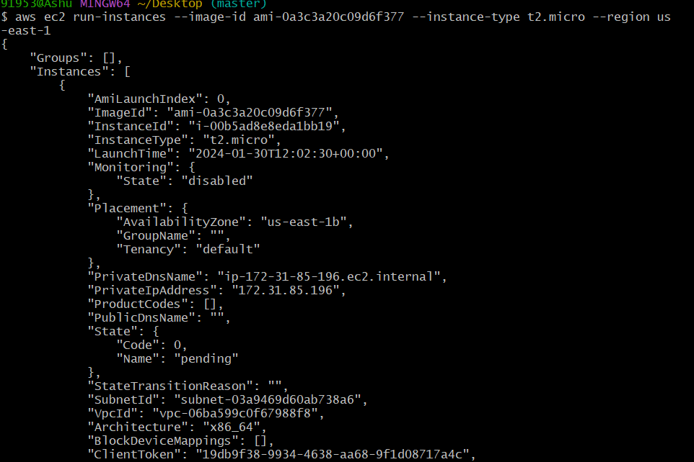

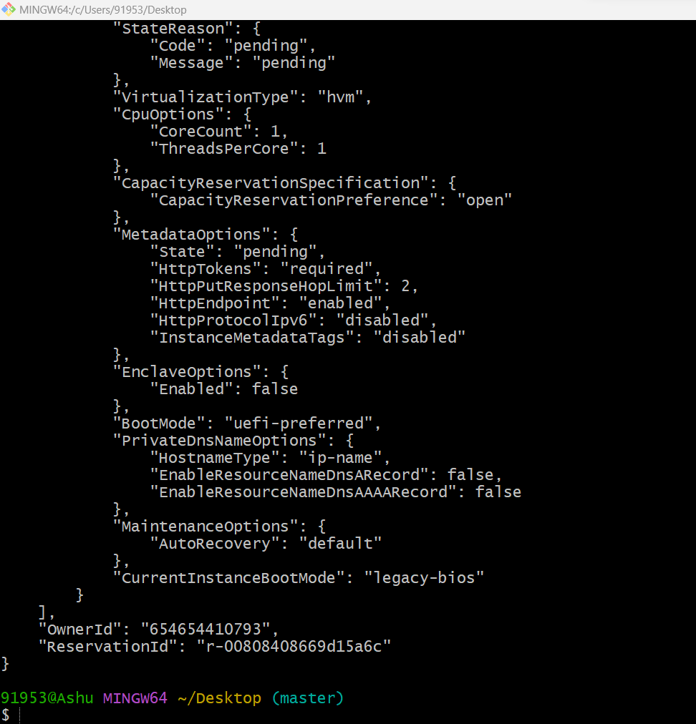

Setup security group in ohio region with name - Techie-sg and open port 22 :-

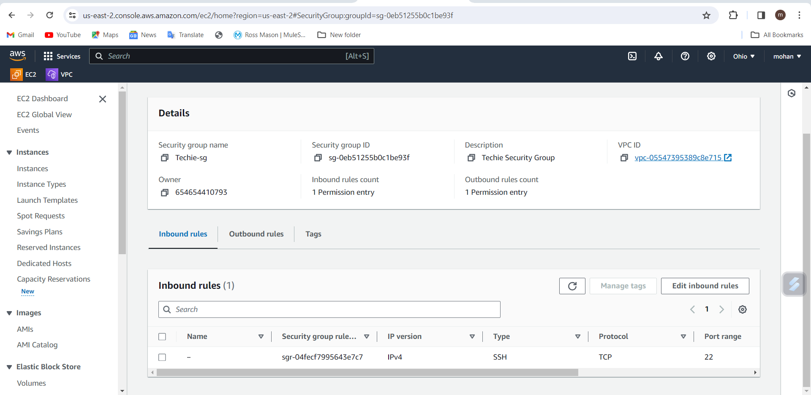

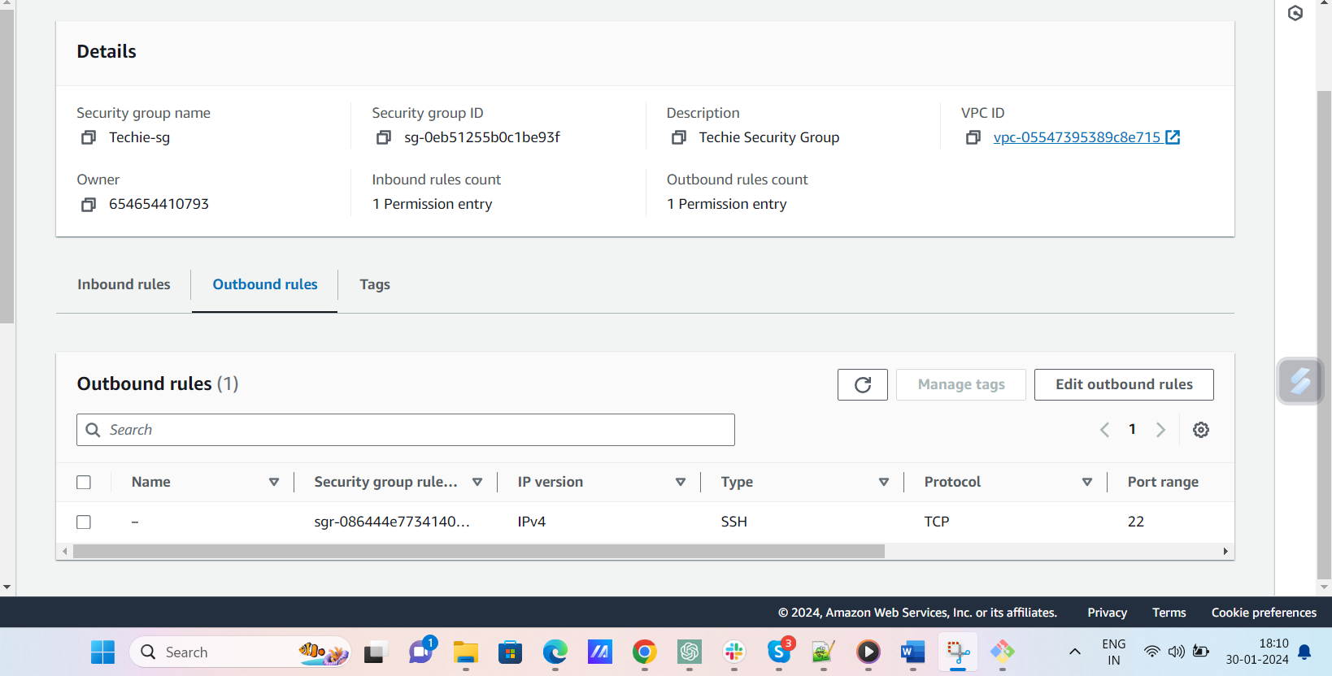

setup ec2,security group in Mumbai region using single aws cli command.

